Report on Food Inflation Dynamics
Objectives
This analysis was guided by three central questions. First, we wanted to understand how expected producer prices (PPI) relate to expected consumer prices (CPI) across major food categories; in order to see how inflationary pressures move through the supply chain. To address this, Excel line charts and Tableau comparison dashboards were used to visualize PPI–CPI relationships across categories. Second, we aimed to identify which CPI categories show the biggest differences between short-term (month-to-month) and long-term (year-over-year) inflation, helping us pinpoint areas of volatility that consumers are most likely to feel. This was examined through Excel bar charts and Tableau volatility dashboards. Third, we examined the accuracy and reliability of forecasted PPI prediction intervals compared to expected CPI values, to assess whether inflation forecasts realistically capture uncertainty and pass-through effects. Tableau scatter plots and Excel forecast tables provided the basis for this comparison. Together, these objectives and visual tools help us solve the broader problem of anticipating how upstream cost shocks translate into consumer-level inflation and where volatility is most likely to disrupt household budgets.
Methodology
To address these questions, we combined structured data analysis with visualization. The Excel charts provided the historical foundation: multi-year CPI bar charts showed how fruit and vegetable prices rose steadily from 2015–2025 with clear seasonal peaks; regression trend lines for January CPI and PPI highlighted the long-term upward trajectory and quantified average annual increases; monthly comparison bar charts revealed seasonal volatility across years; and scatter-style regression plots demonstrated how producer prices (PPI) tracked upward alongside consumer prices (CPI), especially in volatile categories. These visuals established both the long-run inflation trend and the timing differences between producer and consumer price movements.
The Tableau charts built on this by focusing on forecasted dynamics. One dashboard compared expected CPI and PPI across food categories, making it clear where producer cost shocks were passed through to consumers and where they were absorbed. A second dashboard contrasted short-term (month-to-month) and long-term (year-over-year) CPI changes, pinpointing volatility hotspots such as beef and eggs. A third dashboard ranked categories by the size of the CPI–PPI gap, showing which foods had the largest disconnect between producer and consumer inflation.
By layering the Excel trend charts with Tableau’s comparative dashboards, we were able to trace inflationary pressures from farm-level inputs through wholesale markets to consumer prices, while also identifying categories where volatility and pass-through effects are most pronounced. This dual approach ensured that both historical context and forecast uncertainty were captured in a way that makes the findings clear and actionable.
PPI to CPI Relationships
The Excel charts and Tableau dashboards comparing PPI and CPI across food categories reveal that pass-through effects vary widely. In the Excel line charts, beef and eggs stand out with steep producer price increases that are mirrored in consumer prices. Farm-level cattle prices rise more than 22 percent in 2025, which the Tableau comparison dashboard shows translating into nearly a 10 percent CPI increase for beef, with consumer prices remaining elevated even as PPI moderates in 2026. Eggs are even more volatile: the Excel forecast tables highlight a 36 percent surge at the farm level in 2025, and the Tableau scatter plots confirm that CPI eggs climb nearly 20 percent before both measures fall sharply in 2026. By contrast, pork and poultry appear in the Tableau gap analysis with weaker transmission, as wholesale increases yield only modest CPI changes. Dairy, fats and oils, and cereals are shown in both the Excel regression charts and Tableau dashboards as muted pass-through categories, where consumer prices are shaped more by processing and labor costs than raw inputs. Fruits and vegetables, highlighted in the Excel multi-year bar charts, demonstrate another dynamic: even when farm-level prices decline, the Tableau dashboards show consumer prices holding steady, underscoring the role of retail smoothing in buffering households from volatility.
CPI Short-Term vs Long-Term Volatility
The Excel bar charts and Tableau dashboards comparing month-to-month and year-over-year CPI changes highlight clear volatility hotspots. Beef and veal stand out in both sets of visuals, with the Excel forecast tables showing a modest 2.7 percent monthly increase but the Tableau dashboards revealing much larger 13.9 percent annual rise evidence of strong momentum on top of an already elevated base. Eggs are even more unstable: the Excel data shows a slight monthly decline, while the Tableau volatility charts capture a double-digit annual increase and a 31.7 percent year-to-date surge, underscoring their extreme unpredictability. Broader meat categories and beverages also appear in the Tableau comparisons with notable gaps between short- and long-term measures, while staples such as dairy, cereals, and fats and oils remain relatively steady across both Excel and Tableau outputs. Taken together, these visualizations confirm that proteins, especially beef and eggs are the most volatile for consumers, whereas core staples like dairy and bakery products provide greater price stability.
Forecast Intervals and Reliability
The Excel forecast tables and Tableau scatter plots comparing PPI prediction intervals with CPI midpoints show how forecast uncertainty plays out across categories. In the Tableau visuals, cattle and eggs stand out with the widest ranges, reflecting structural shocks, while dairy and bakery categories display much narrower intervals due to diversified cost structures. The Excel data highlights cattle forecasts spanning 18 to 27 percent in 2025, which the Tableau plots show translating into CPI beef increases of around 9.5 percent evidence of partial pass-through and retail smoothing. Eggs are even more volatile: the Excel tables project extremely broad ranges from 23 to 61 percent in 2025 and from -76 to 127 percent in 2026, while the Tableau scatter plots confirm that CPI eggs follow the same direction but at smaller magnitudes. Together, these visuals demonstrate that CPI forecasts realistically acknowledge volatility but moderate extreme producer swing, underscoring how consumer markets buffer households from the full impact of upstream shocks.
Key Findings
The Excel charts and Tableau dashboards confirm that pass-through from producer to consumer prices is uneven across food categories. In the Excel forecast tables and Tableau comparison dashboards, beef and eggs show the strongest transmission, with sharp producer price increases translating into noticeable CPI gains. Dairy, cereals, and produce, however, appear in both sets of visuals as weaker links, since consumer prices in these categories are shaped more by processing and retail smoothing than raw inputs. Volatility is concentrated in proteins: the Tableau short-term vs long-term CPI charts highlight beef and eggs as categories with large gaps between monthly and annual changes, making them the most unpredictable for shoppers. Forecast reliability is also captured in the Excel prediction intervals and Tableau scatter plots, which show wide ranges for volatile categories like cattle and eggs, while CPI midpoints fall within those ranges but at smaller magnitudes evidence that consumer forecasts realistically moderate producer volatility. Finally, the Excel multi-year bar charts and Tableau dashboards on fruits and vegetables illustrate seasonal swings at the farm level, yet consumer prices remain relatively stable, underscoring how retail smoothing shields households from extreme fluctuations.
Conclusion
By integrating the Excel forecast tables with Tableau dashboards, this analysis provides a clear, structured view of how inflation moves through the food supply chain. The Excel charts established the historical trends and quantified forecast ranges, while the Tableau visuals highlighted category-specific pass-through, volatility hotspots, and CPI–PPI gaps. Together, these tools showed where producer costs most strongly affect consumer prices, where volatility is concentrated, and how forecast intervals realistically capture uncertainty. The combined findings give policymakers, retailers, and consumers a practical framework for anticipating inflationary pressures and adjusting strategies to manage costs, spending, and expectations in an environment where beef and eggs remain volatile while staples like dairy and cereals provide greater stability.
Tableau Charts
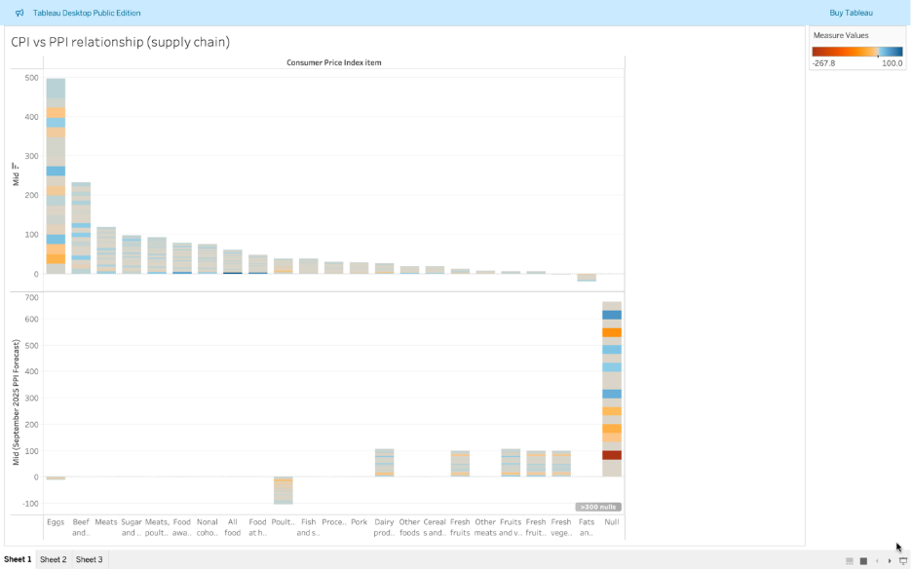
Goal: Compare expected Producer Price Index (PPI) to expected Consumer Price Index (CPI) across food categories. (Top is CPI, and bottom is PPI)
Chart 1 shows that producer price inflation (PPI) does not affect all food categories equally. Meats, dairy, and fats & oils show strong pass-through from producer to consumer prices, while fresh produce categories show weaker alignment, suggesting greater volatility and outside factors.
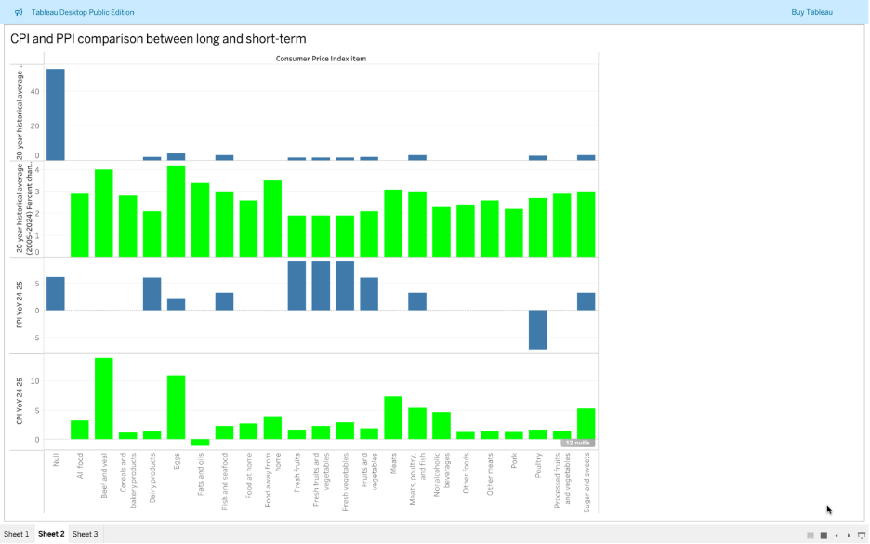
Goal: Show how PPI and CPI compare over long-term vs short-term trends. (Blue is the forecast and Green is the result.)
Chart 2 highlights which categories experienced the biggest differences between long-term inflation and short-term changes. Eggs, cereals/bakery products, and sugar show significant spikes relative to their 20-year averages, while fresh fruits and vegetables fell below historical norms. This reveals where consumers are facing the most (or least) pressure.
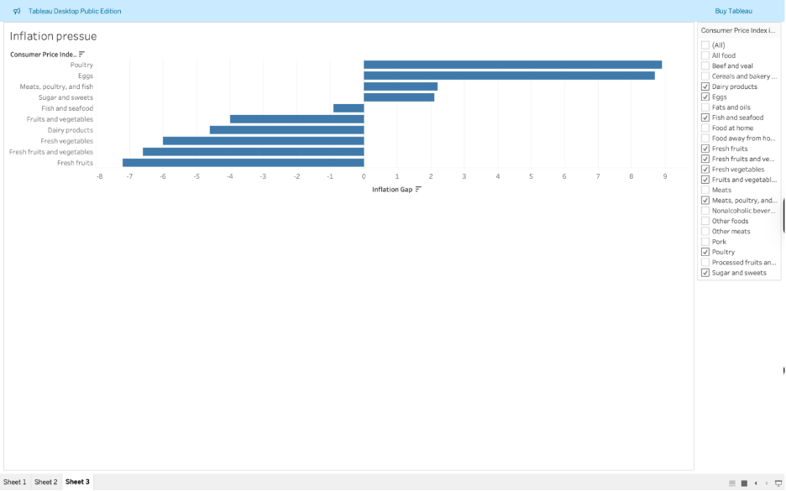
Goal: Show which categories have the highest gap between PPI and CPI, where producer prices are passed on to consumers.
Chart 3 evaluates forecast accuracy through the inflation gap. Forecasts underestimated inflation in poultry, eggs, and meats, while overestimating inflation for fruits and vegetables. This indicates uneven reliability in producer-to-consumer price forecasting.

Excel Charts
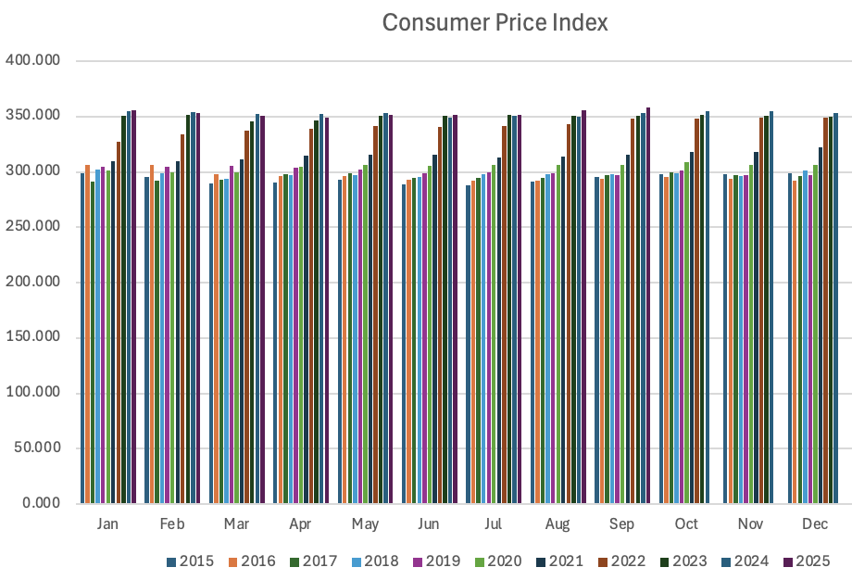

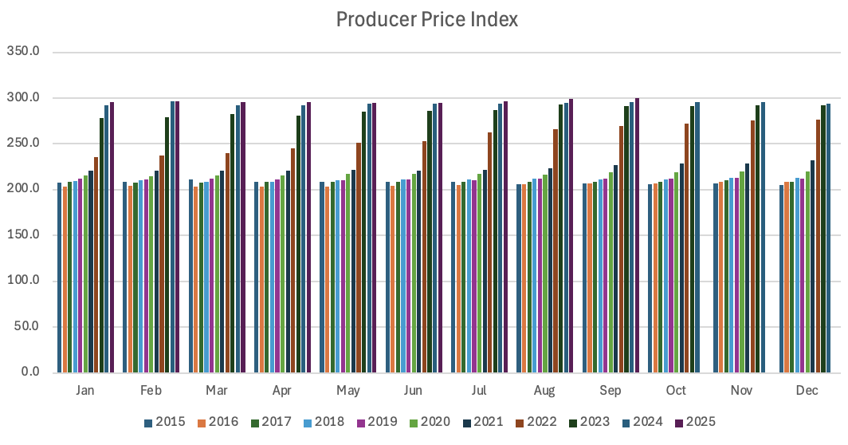
The above bar graphs show how both CPI and PPI have gone up sense 2015. It also shows how CPI and PPI are not related to what month it is. Lastly, this shows PPI catching CPI in the last couple of years.
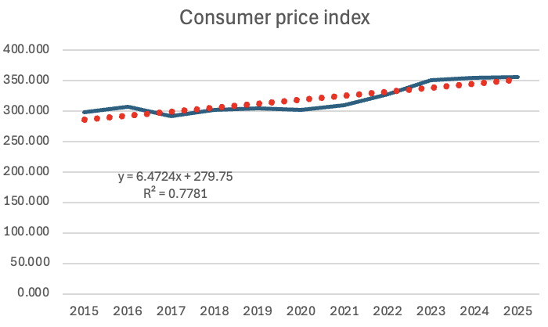

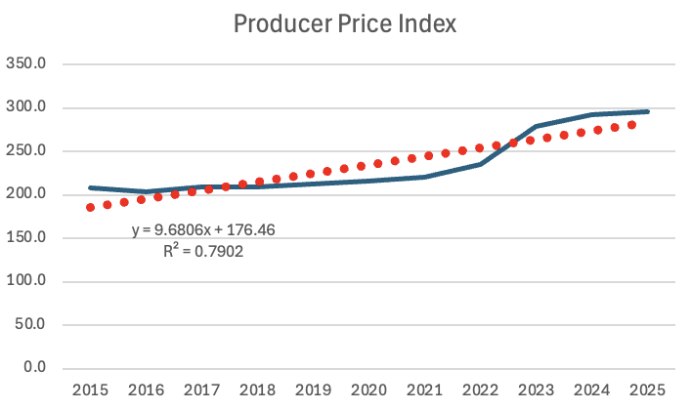
The above line graphs show the growth of CPI and PPI over the last 10 years. The equations show how PPI has grown quicker over the past decade.

